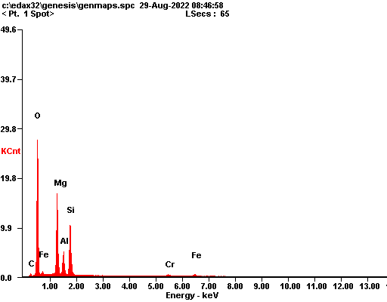

|  |  |  |
| --- | --- | --- |
| ***Element*** | ***Wt%*** | ***At%*** |
| ***CK*** | 02.83 | 04.78 |
| ***OK*** | 45.12 | 57.18 |
| ***MgK*** | 21.77 | 18.15 |
| ***AlK*** | 07.15 | 05.38 |
| ***SiK*** | 16.88 | 12.18 |
| ***CrK*** | 02.07 | 00.81 |
| ***FeK*** | 04.18 | 01.52 |
| ***Matrix*** | Correction | ZAF |

